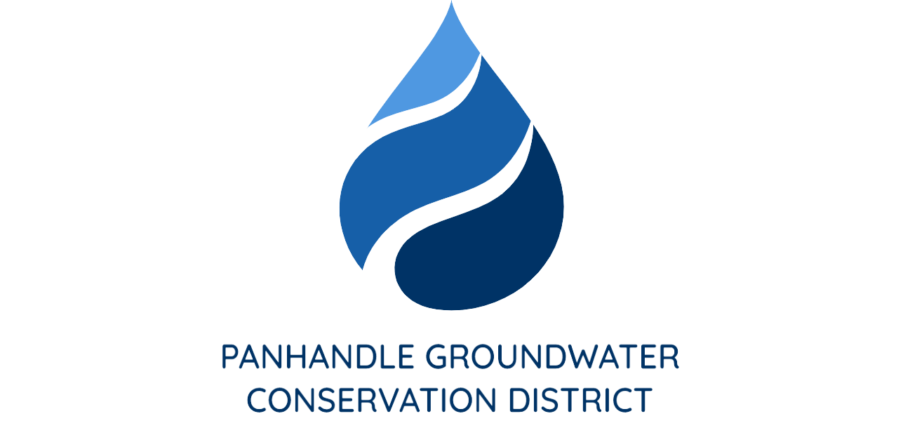

PRESS RELEASE
Contact: Britney Britten, General Manager
Panhandle Groundwater Conservation District
(806) 883-2501
britney@pgcd.us

FOR IMMEDIATE RELEASE

Panhandle Groundwater District Scholarship Winners

WHITE DEER, TX. (May 25, 2022) – Since 2002, Panhandle Groundwater Conservation District (PGCD) has provided $180,000 in scholarship funds to deserving high school seniors in our District. The scholarship is based off grades, extracurricular activity involvement, financial need and an essay with the topic provided by the District. A total of 18 students applied this year.

PGCD is proud to announce its top three winners. First place is Kollier Miller from Panhandle High School, receiving a $4,000 scholarship, second place is Keely Harding from Panhandle High School, receiving a $3,000 scholarship and third place is Anthony Haiduk from White Deer High School, receiving a $2,000 scholarship.

PGCD wants to thank all of the applicants and congratulate the winners. We thoroughly enjoyed each essay and perspective on this year’s topic. Congruatlations to all graudating seniors this year, and we wish you the best of luck on your future endeavors.

